CSCE 560

2nd Lt David Crow

Wireshark Lab 5





1. Are DHCP messages sent over UDP or TCP?

DHCP is sent over UDP.

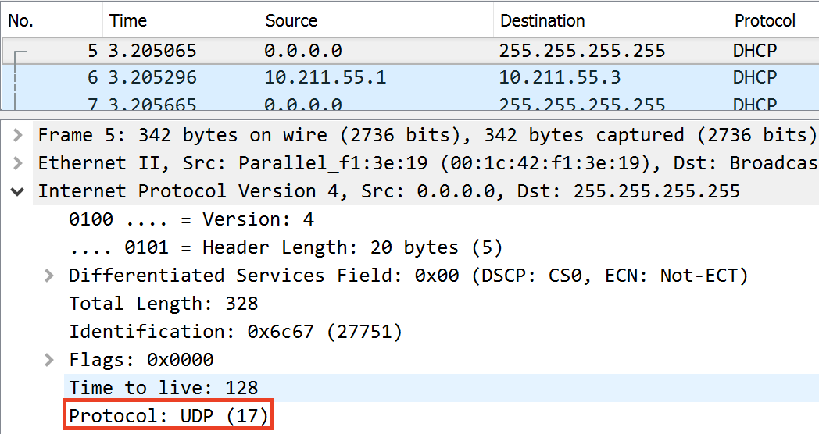

1. Draw a timing diagram illustrating the sequence of the first four-packet Discover/Offer/Request/ACK DHCP exchange between the client and server. For each packet, indicate the source and destination port numbers. Are the port numbers the same as in the example given in this lab assignment?



The port numbers, as shown below, are the same as in the example. I’ve provided a single screenshot that indicates where I found the port numbers for the DHCP discover message. I found the port numbers for the other DHCP messages in their respective locations in the UDP fields.

|  |  |  |
| --- | --- | --- |
| **DHCP Message** | **Source Port Number** | **Destination Port Number** |
| Discover | 68 | 67 |
| Offer | 67 | 68 |
| Request | 68 | 67 |
| ACK DCHP | 67 | 68 |

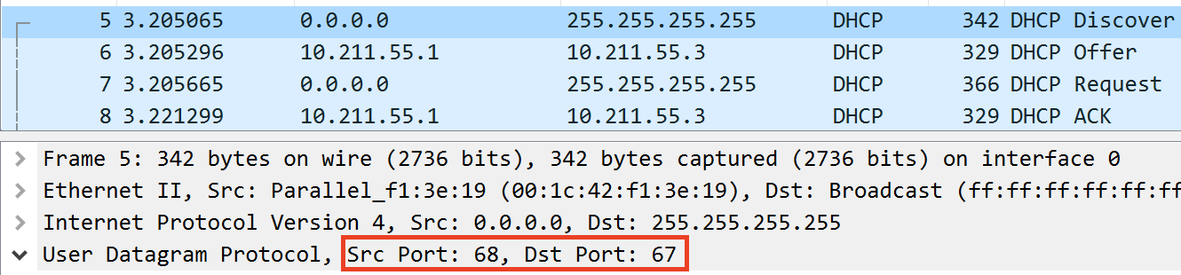

1. What is the link-layer (e.g., Ethernet) address of your host?

The link-layer address of my host (a Parallels VM running Windows 10 on an OSX computer) is 00:1c:42:f1:3e:19.

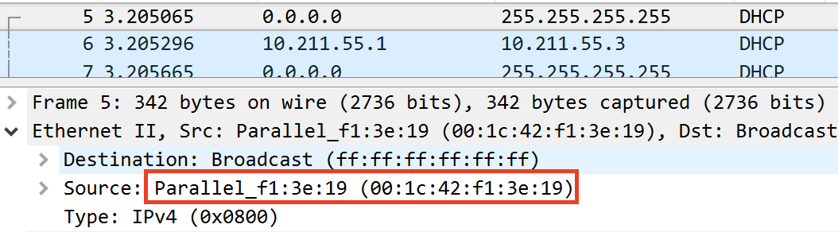

1. What values in the DHCP discover message differentiate this message from the DHCP request message?

Option 53 in the discover message indicates that it is a discover message. Option 53 in the request message indicates that it is a request message.

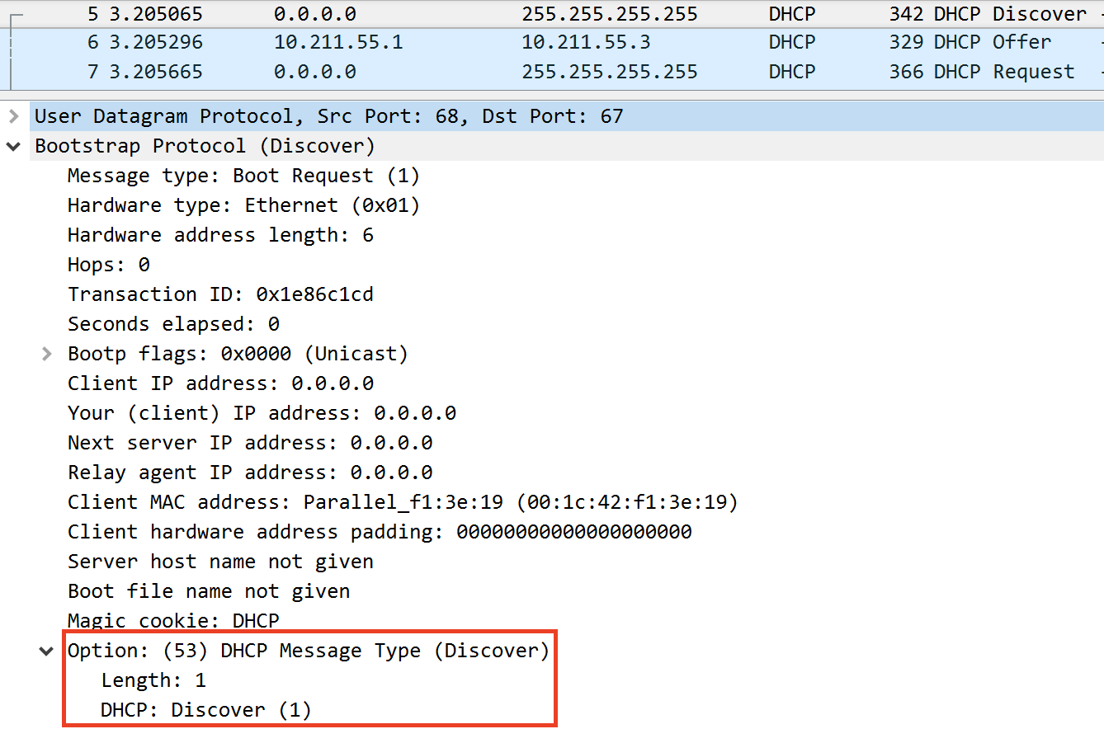

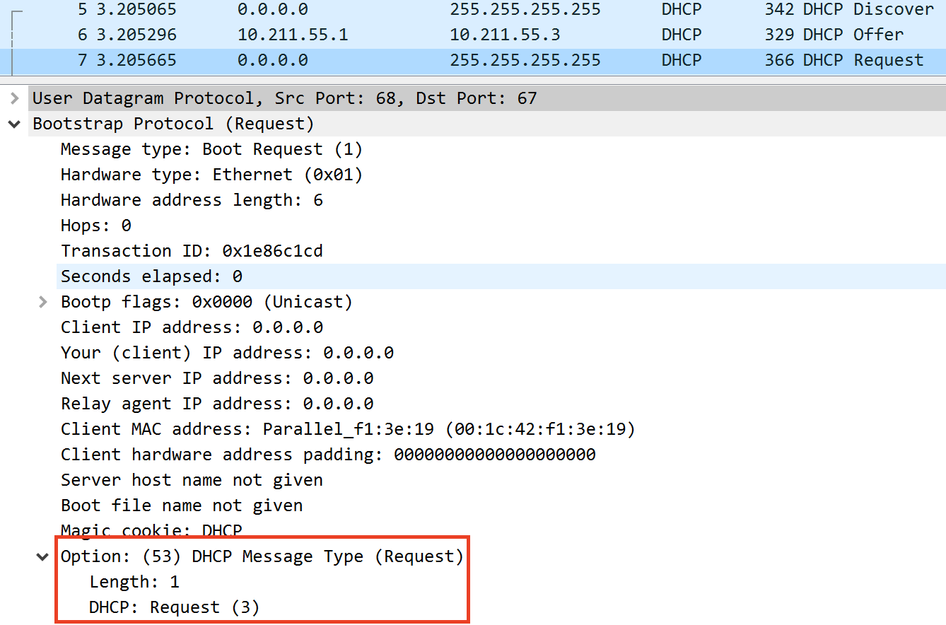

1. What is the value of the Transaction-ID in each of the first four (Discover/Offer/Request/ACK) DHCP messages? What are the values of the Transaction-ID in the second set (Request/ACK) set of DHCP messages? What is the purpose of the Transaction-ID field?

The transaction ID is 0x1e86c1cd for each of the first four DHCP messages. The transaction ID is 0x9aa172a3 for the next two DHCP messages. The transaction ID identifies a given transaction (this is obvious) so a client can tell whether an offer, for example, is related to a previous DHCP message.

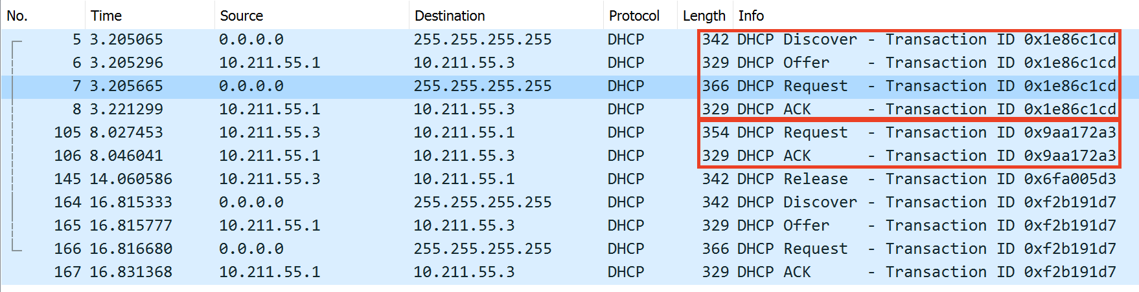

1. A host uses DHCP to obtain an IP address, among other things. But a host’s IP address is not confirmed until the end of the four-message exchange! If the IP address is not set until the end of the four-message exchange, then what values are used in the IP datagrams in the four-message exchange? For each of the four DHCP messages (Discover/Offer/Request/ACK DHCP), indicate the source and destination IP addresses that are carried in the encapsulating IP datagram.

|  |  |  |
| --- | --- | --- |
| **DHCP Message** | **Source IP Address** | **Destination IP Address** |
| Discover | 0.0.0.0 | 255.255.255.255 |
| Offer | 10.211.55.1 | 10.211.55.3 |
| Request | 0.0.0.0 | 255.255.255.255 |
| ACK DHCP | 10.211.55.1 | 10.211.55.3 |



1. What is the IP address of your DHCP server?

The DHCP offer came from the DHCP server at IP address 10.211.55.1.

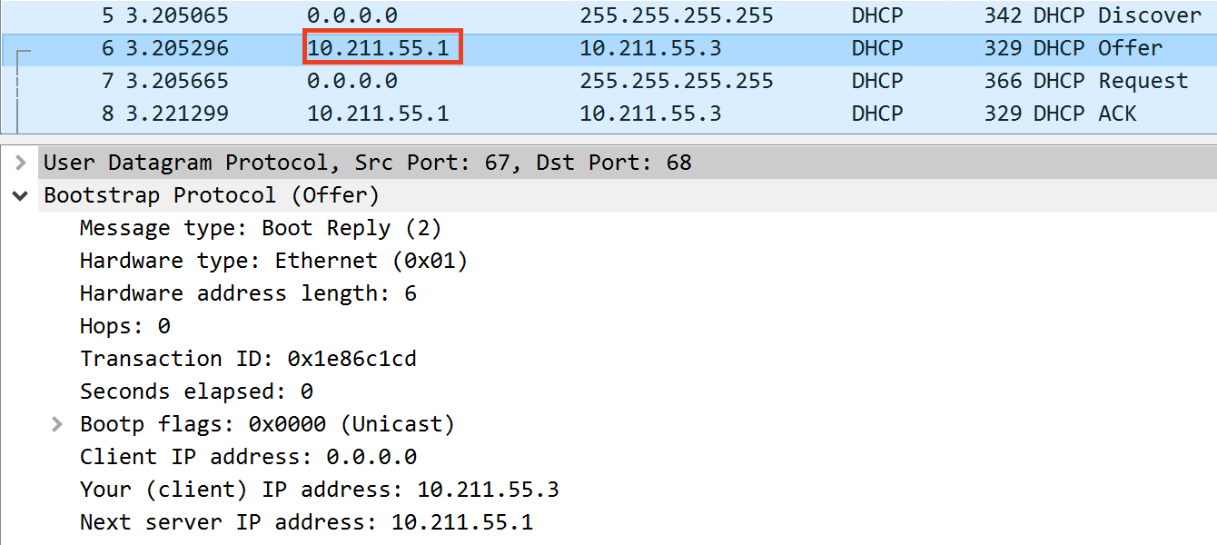

1. What IP address is the DHCP server offering to your host in the DHCP Offer message? Indicate which DHCP message contains the offered DHCP address.

The DHCP server is offering 10.211.55.1 to my host. The second DHCP message – where option 53 indicates that the message *is* a DHCP offer – contains the offered address.

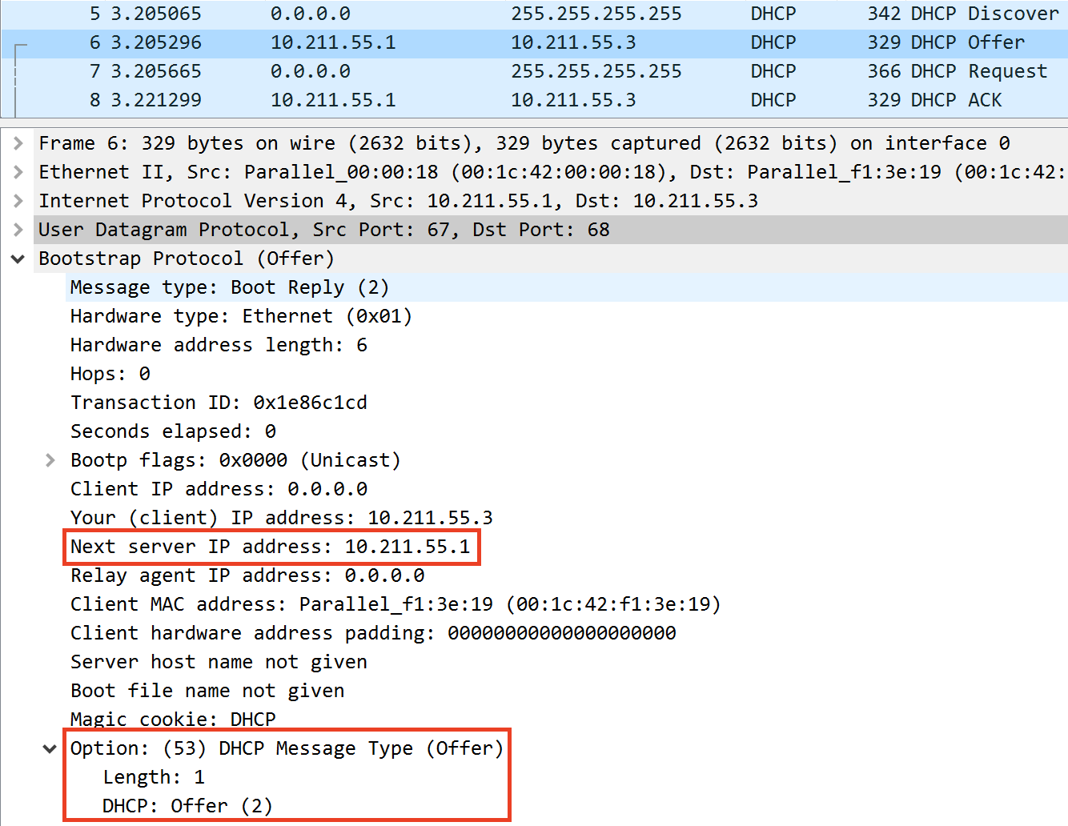

1. In the example screenshot in this assignment, there is no relay agent between the host and the DHCP server. What values in the trace indicate the absence of a relay agent? Is there a relay agent in your experiment? If so, what is the IP address of the agent?

We know the example didn’t use a relay agent because the first source IP address is 0.0.0.0. In my experiment, too, the first source IP address is 0.0.0.0, so we know there is no relay agent.

1. Explain the purpose of the router and subnet mask lines in the DHCP offer message.

The router line indicates the IP address of the default internet gateway for the network. The subnet mask line indicates the availability of a subnet for the network.

1. In the DHCP trace file noted in footnote 2, the DHCP server offers a specific IP address to the client (see also question 8 above). In the client’s response to the first server OFFER message, does the client accept this IP address? Where in the client’s RESPONSE is the client’s requested address?

The server offered 192.168.1.101. The client then requested (in option 50) 192.168.1.101. Thus, the client accepted the offer.

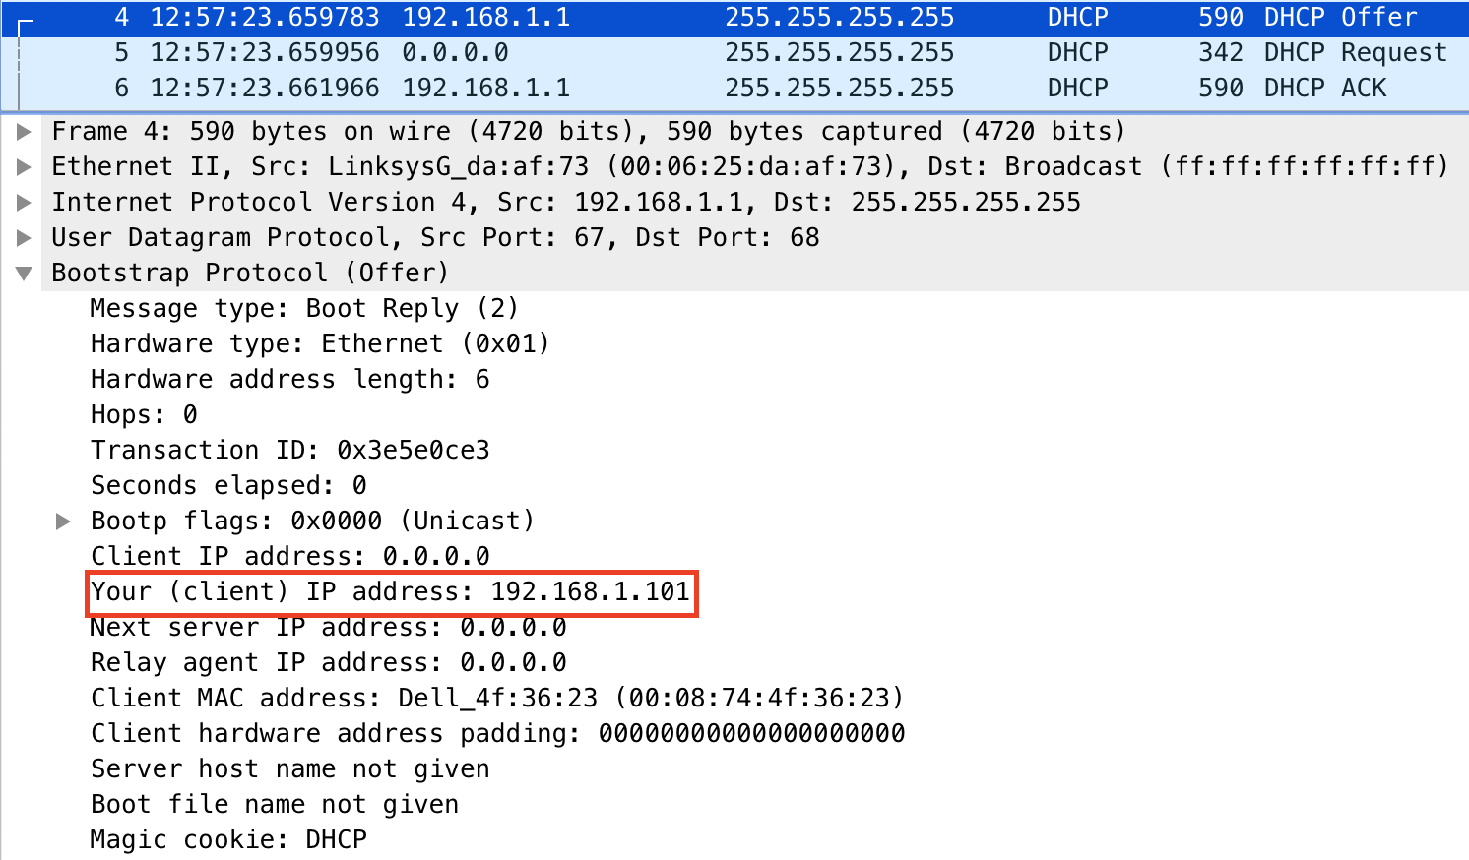

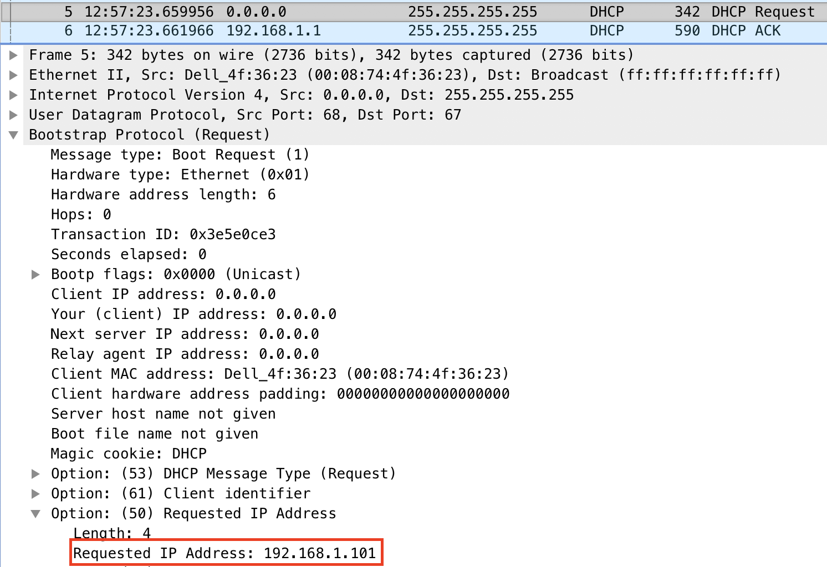

1. Explain the purpose of the lease time. How long is the lease time in your experiment?

The lease time is the amount of time a user is allowed to use the offered IP address. My lease time is 30 minutes.



1. What is the purpose of the DHCP release message? Does the DHCP server issue an acknowledgment of receipt of the client’s DHCP request? What would happen if the client’s DHCP release message is lost?

The DHCP release message allows the client to indicate to the server that it no longer needs the leased IP address. The DHCP server does not ACK this request.

If the DHCP release message is lost, the server will simply retain the leased IP address until the lease time elapses.

1. Clear the *bootp* filter from your Wireshark window. Were any ARP packets sent or received during the DHCP packet-exchange period? If so, explain the purpose of those ARP packets.

Some ARP packets were sent. They work to map an ethernet address to an IP address.

